**APCSP Activity 1.3.6: Tuples and Lists**

Learning Target: Define the problem and analyze research to create a solution to a problem.

**Step 7**

1. Explain the following output:

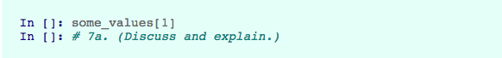

The input returns the 2nd value in the some_values array.

1. Explain the following output:

Screen Shot 2017-10-25 at 1.41.40 PM.png

The input returns another array but only contains the 1st to 3rd value in the some_values array.

**Step 8**

Define a ‘tuple’.

|  |
| --- |
| tup = (1, 5.6, 'string') |

Explain the following output:

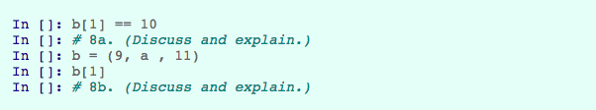

The input would return 15 because tuple was redefined which refreshed the variable ‘a’ which happens to be the 2nd value in the tuple.

**Step 9**

Explain the following output:

Screen Shot 2017-10-25 at 2.09.43 PM.png

The input returns another tuple that contains all of the data in values except for the first value because the index selector selects values 1 and up.

**Step 10**

Explain the following output:

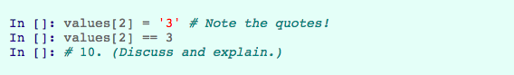

When defining a tuple any string that’s completely numeric automatically gets converted into a number.

**Step 11**

Explain the following output:

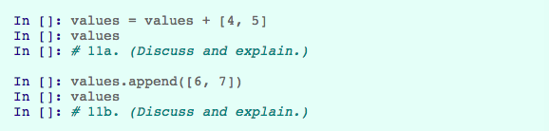

The first input returns the array of values but with the 4 and 5 values added onto it.

The second input returns the array but instead of adding 2 new values to it, it adds 1 value that’s an array so it would return [‘a’, ‘b’, 3, [6, 7]]

**Step 12**

Explain why the code below does not work.

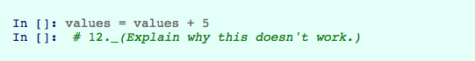

Because values and 5 are not the same type of variable, you can only add arrays to other arrays and numbers to other numbers.

**Step 13**

Explain the following output:

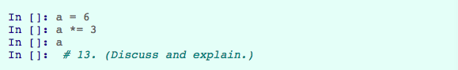

The input would return 18 because the *= operator is basically returning the initial value multiplied by whatever was specified.

**Step 15**

Define a function roll_two_dice() that simulates rolling two six-sided dice and returns the total.

Screen Shot 2017-10-25 at 2.15.54 PM.png

|  |
| --- |
| import random  def roll_two_dice():  dice = []  dice.append(randint(1, 6))  dice.append(randint(1, 6))  return dice[0] + dice[1] |

**Step 16**

Define a function guess_letter() that will pick one letter randomly from the alphabet.

|  |
| --- |
| def guess_letter():  alphabet = 'abcdefghijklmnopqrstuvwxyz'  return random.choice(alphabet) |

**Conclusion Questions**

1. Consider a string, tuple, and list of characters.

In []: a = 'abcde'  
 In []: b = ('a', 'b', 'c', 'd', 'e')  
 In []: c = ['a', 'b', 'c', 'd', 'e']

The values of a[3], b[3], and c[3] are all the same. In what ways are a, b, and c different?

a is a string, b is a tuple, and c is an array.

2. Why do computer programming languages almost always have a variety of variable types? Why can't everything be represented with an integer?

Because it’s easier for developers to work with multiple variable types. If every variable was represented with an integer, you would need to encode any string into base-10 and that would be a pretty tedious process. At the core everything is binary but different variable types have different ways of interpreting snippets of binary.